Benjamin Larose
IT 491
Sprint 2 QA

Version of pkt tracer file tested: 10-25-26 SSH Configuration update

Verification of DHCP/relay and DNS tests (US-09/10/24/25): PASS
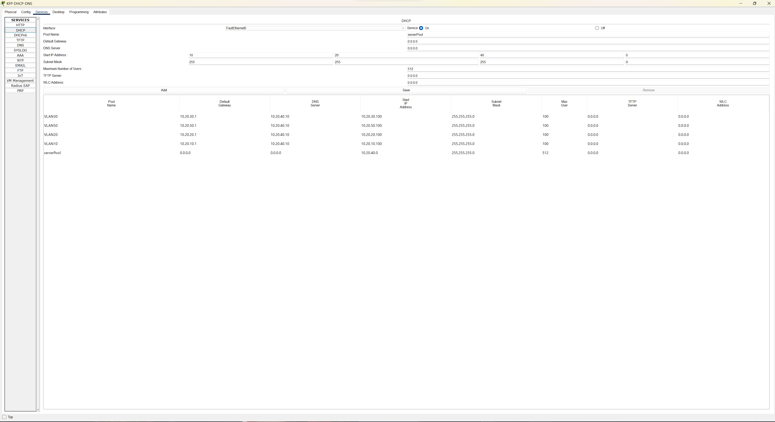
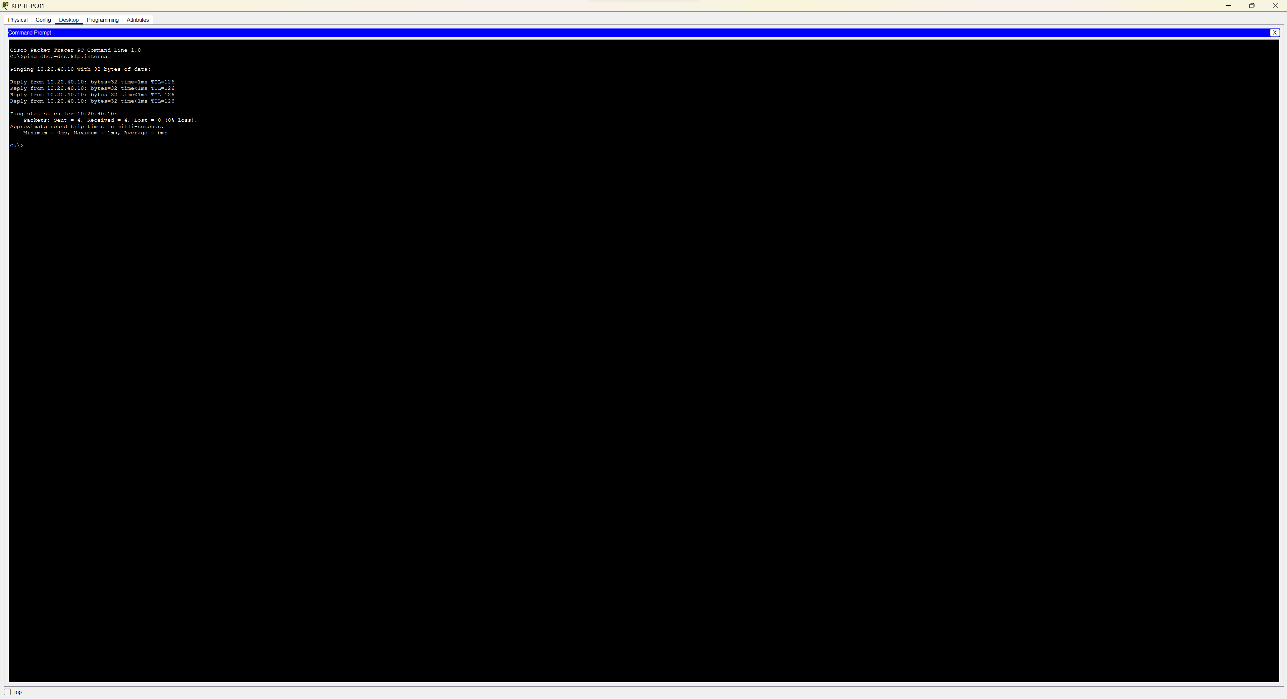

Review of NTP configuration and synchronization evidence (US-13): PASS (clock time was consistent across devices on the network)

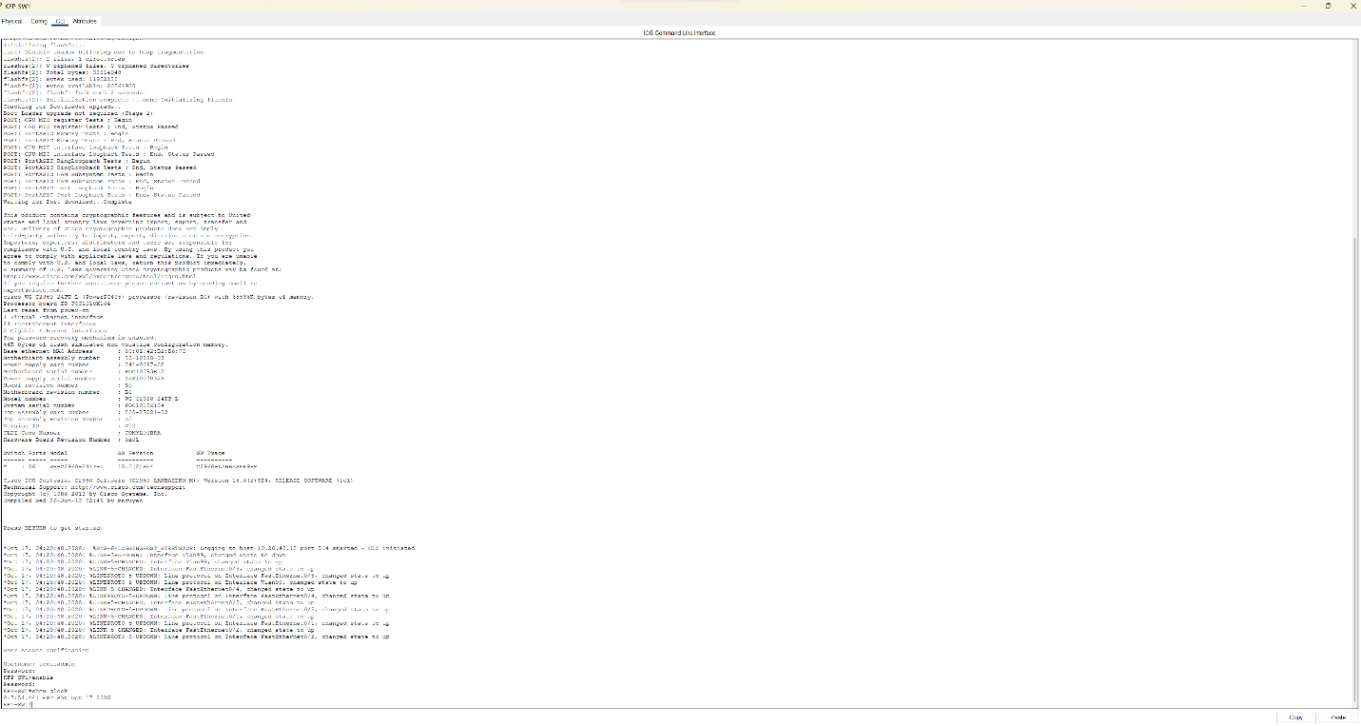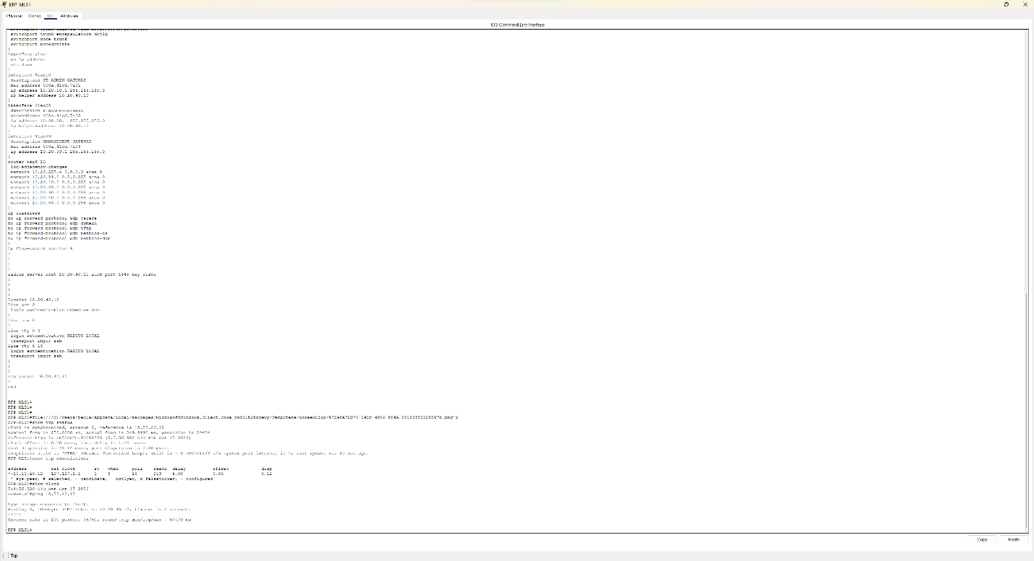

Verification of RADIUS/AAA and local fallback (US-07): PASS (for the fallback test, the radius server was disconnected, and I attempted to connect to MLS1 using the local credentials and succeeded.)

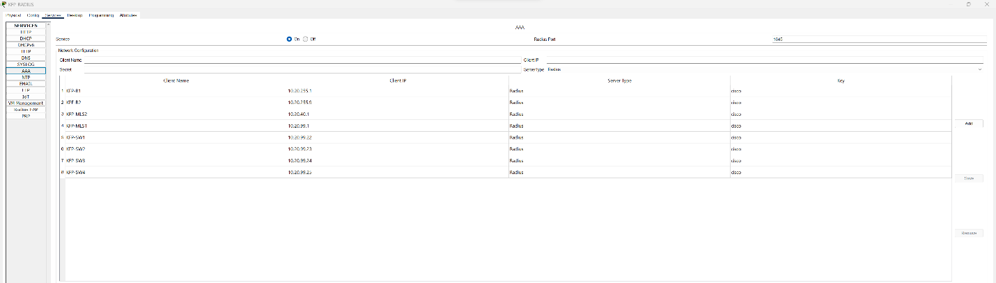
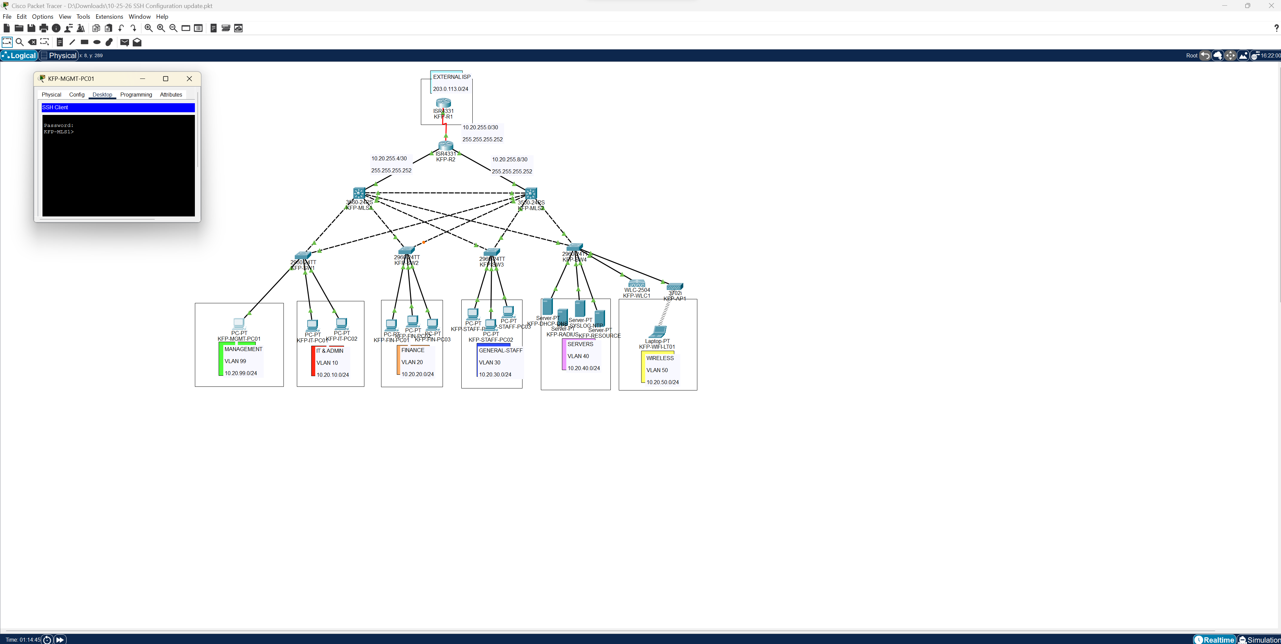

Verification of SSHv2 and Telnet rejection (US-08): PASS (ssh demonstrated in prior screenshot)
